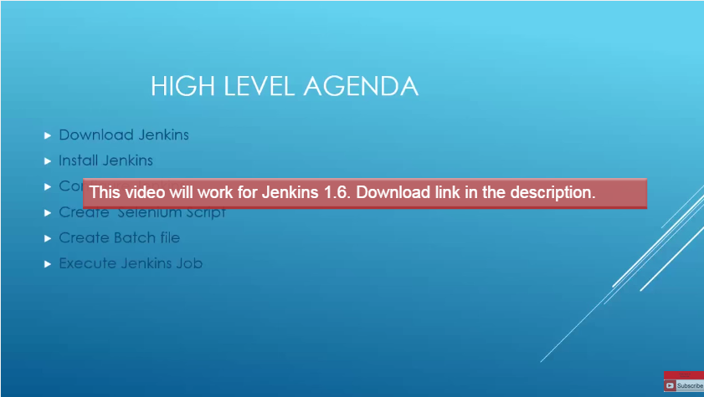

1. Download Jenkins from website

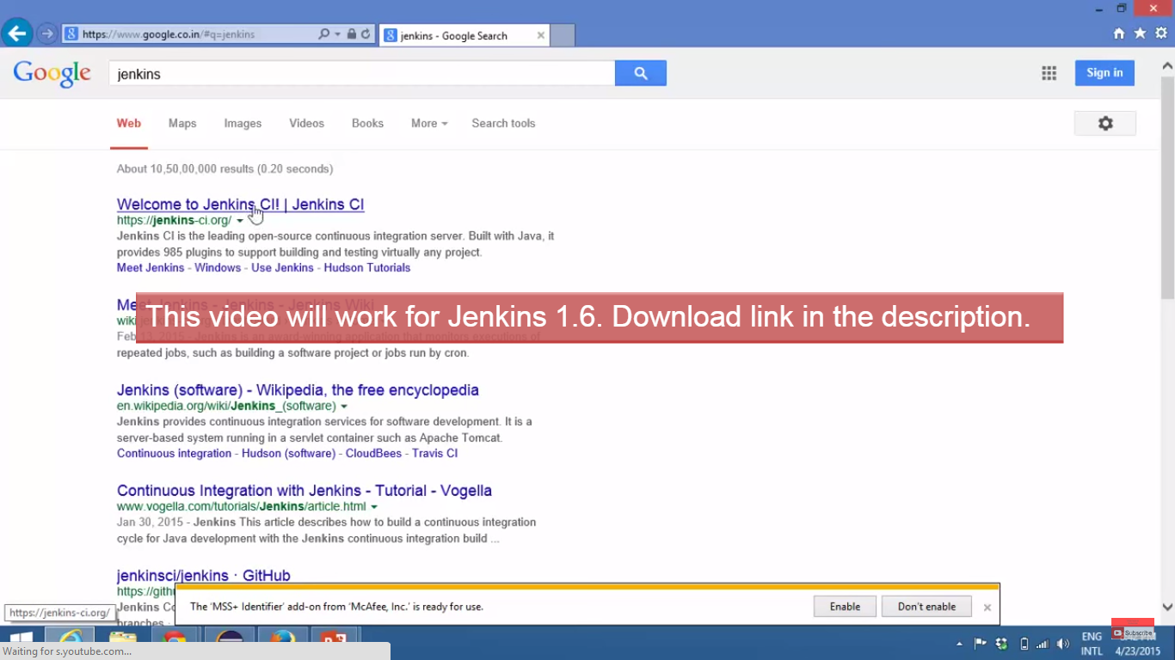

1. Download latest version of Jenkins: 1.6

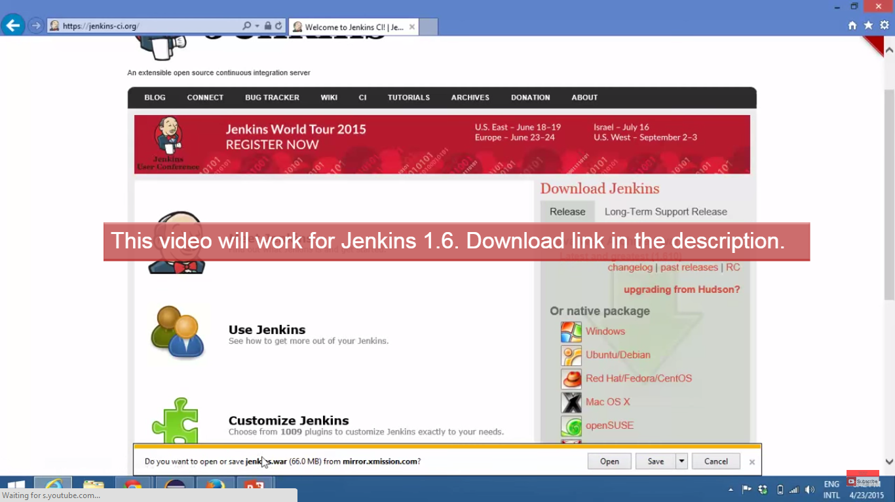

1. Jenkins. War file will get downloaded

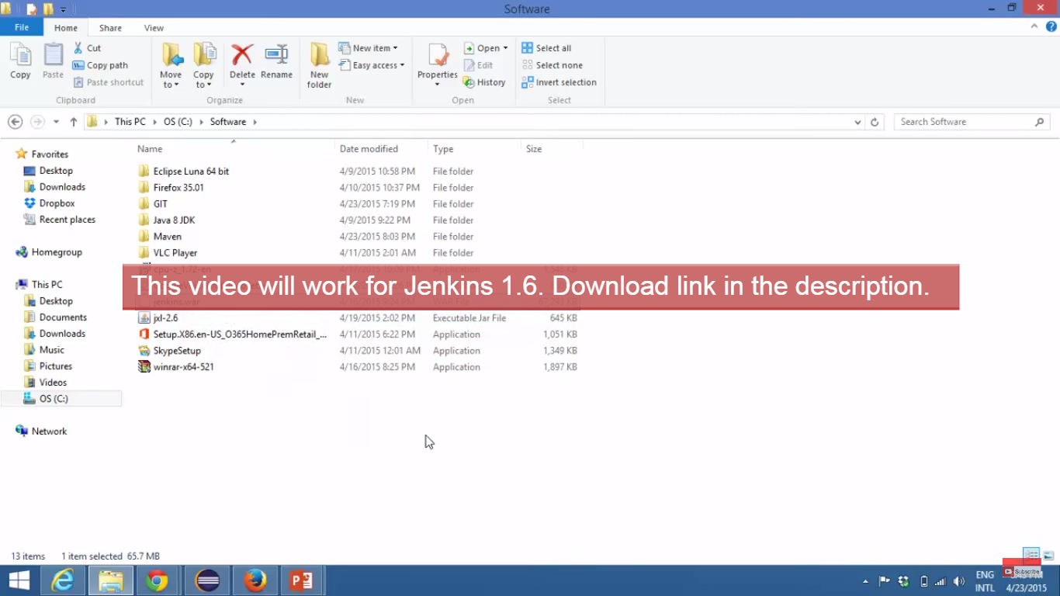

1. Open command prompt

Type java – jar and drag and drop that war file in cmd prompt

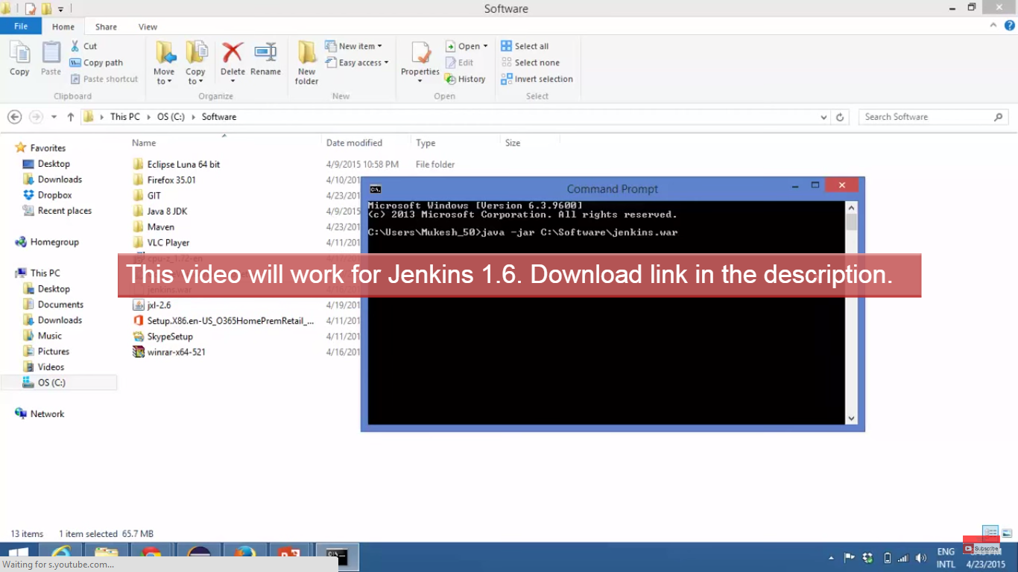

1. It will take some time to start with Jenkins server.Create a new java project

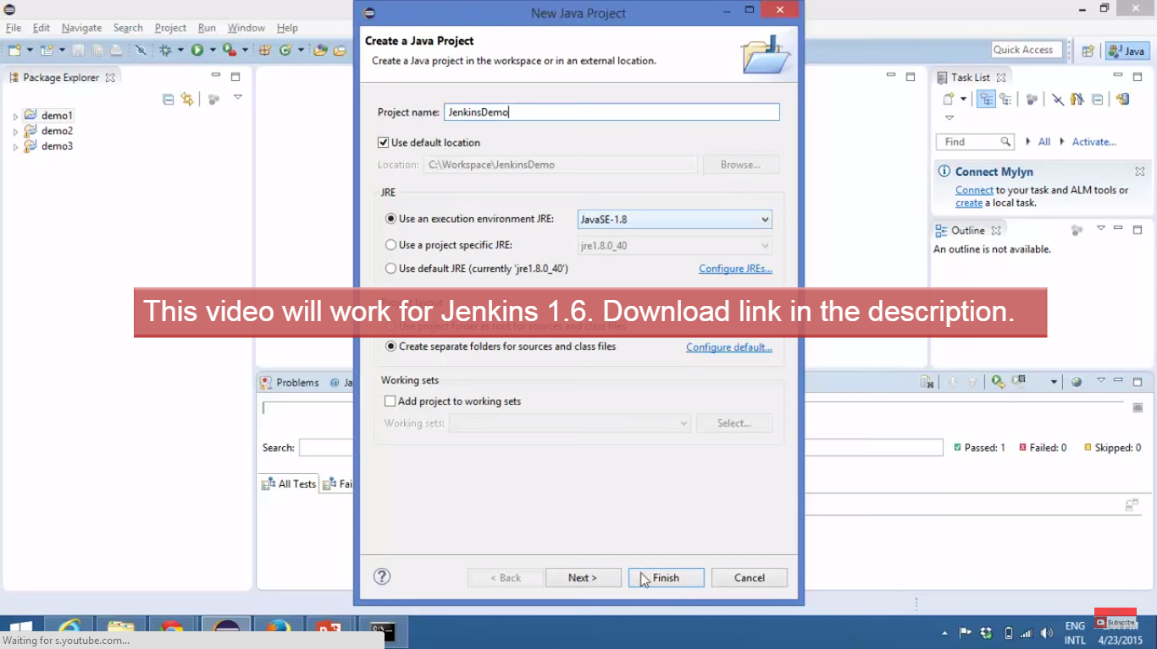

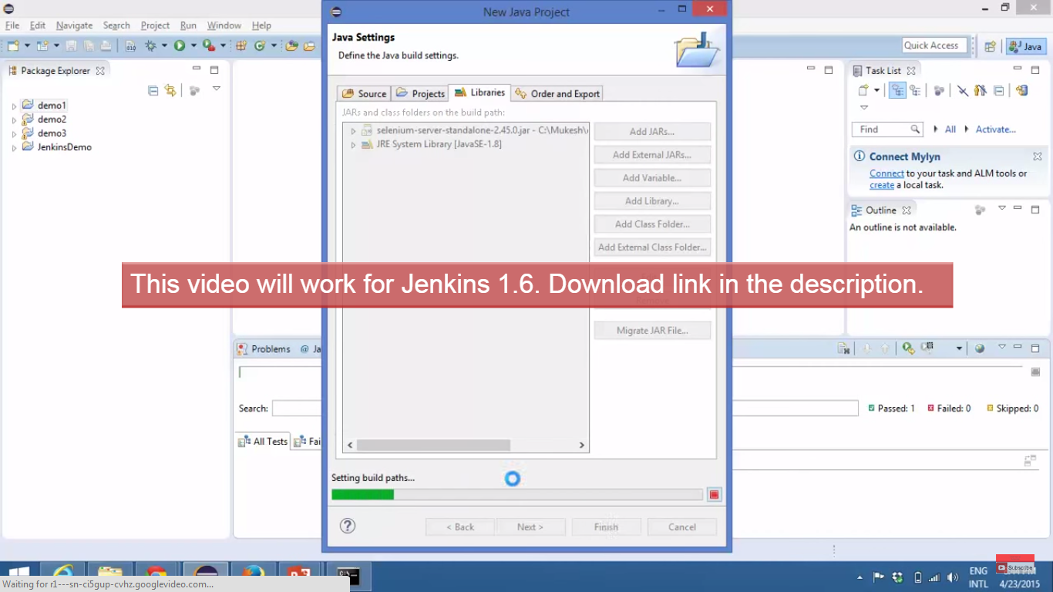

1. Check whether Jenkins is up and running

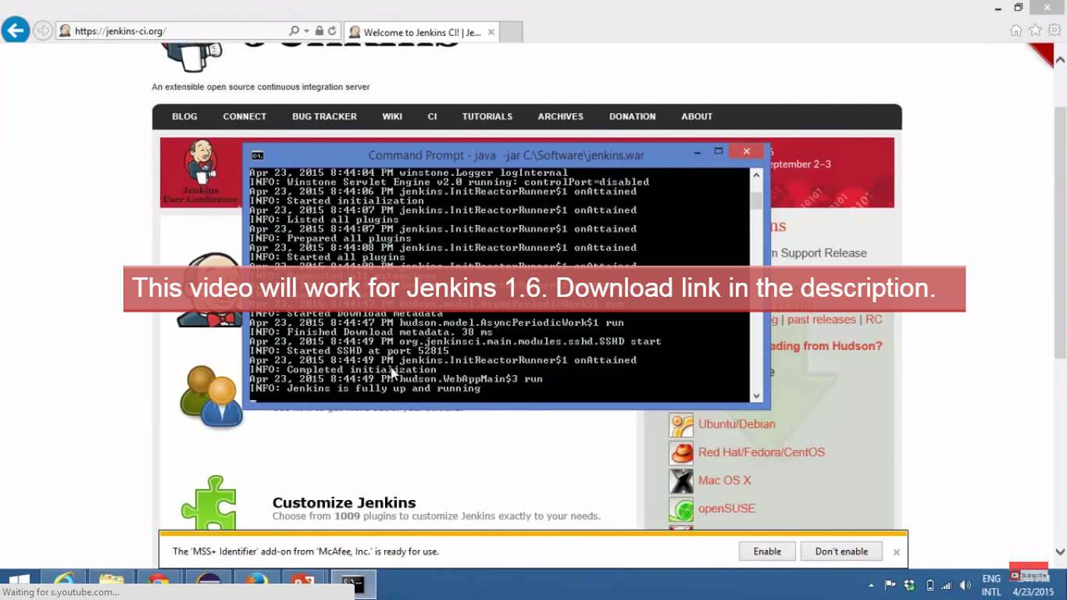

1. Type <http://localhost:8080> and copy paste in browser

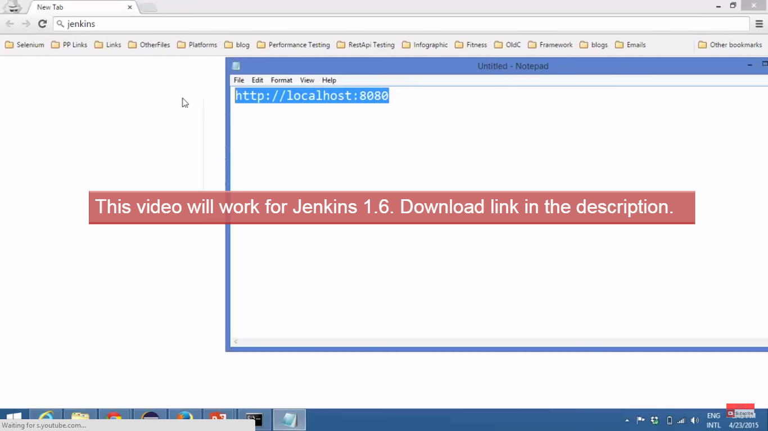

1. Jenkins page will open

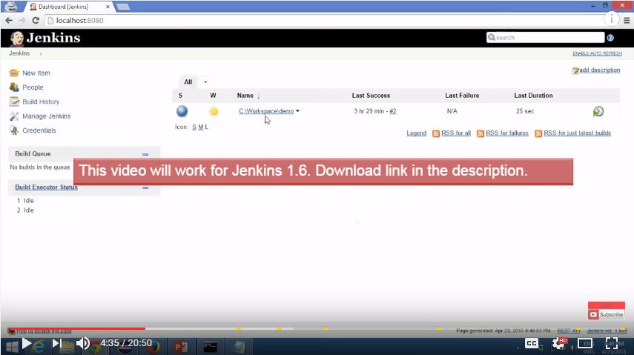

1. Click on a Manage Jenkins to configure

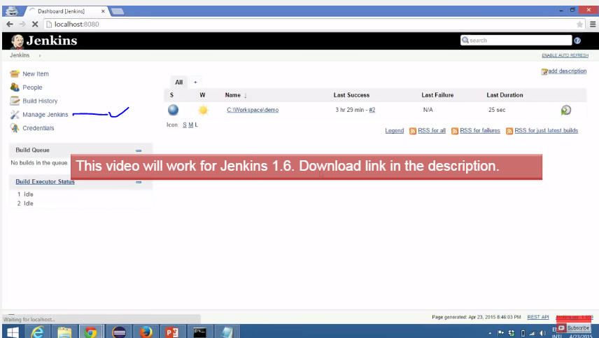

1. Click on Configure System

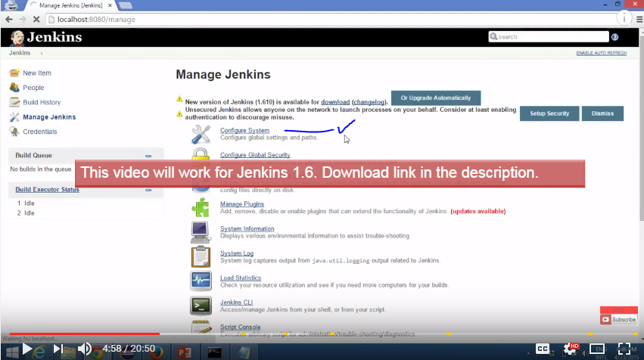

1. Copy JDK path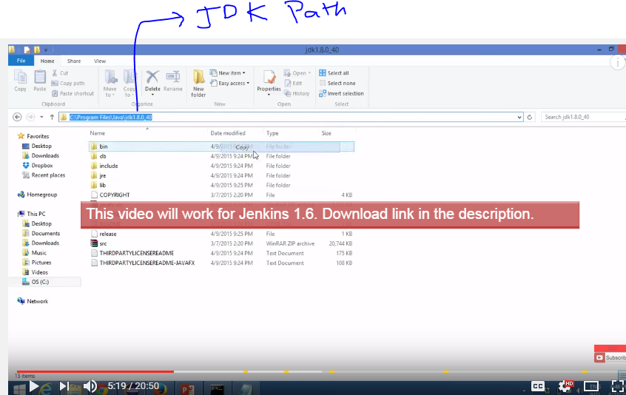
2. Click on JDK installation

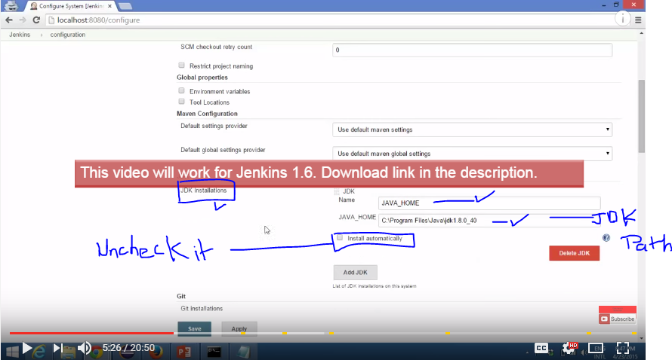

1. Click on Apply and Save

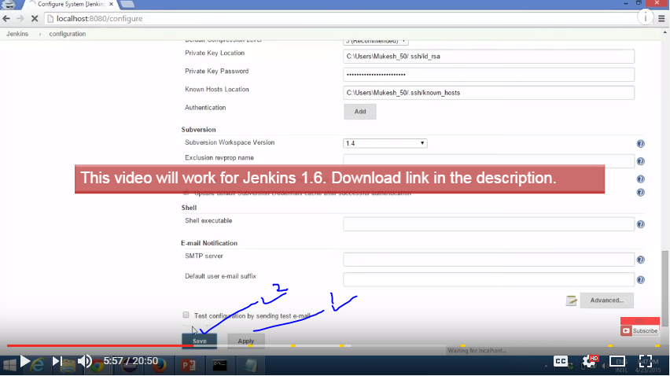

1. Create a java project

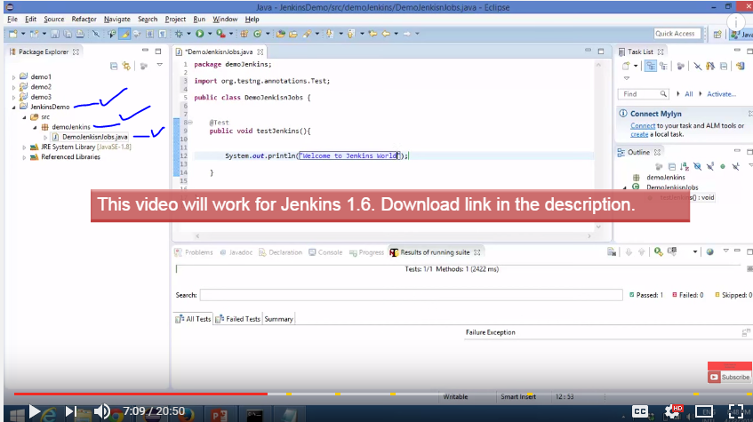

1. We need to create an xml file so that we can run it with xml. For that we need to Go to

TEST NG-🡪 CONVERT TO TESTNG

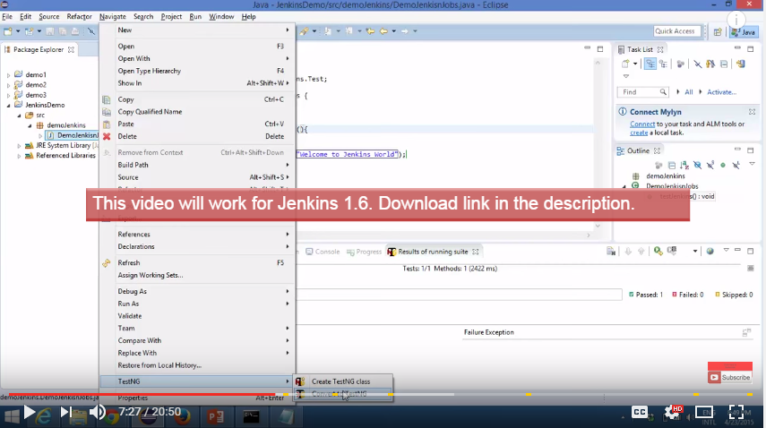

1. **GENERATING TESTING.XML**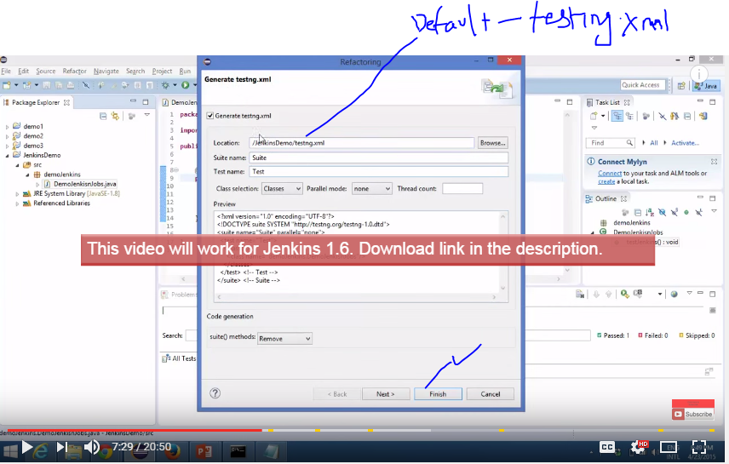
2. **Click** on testing.xml

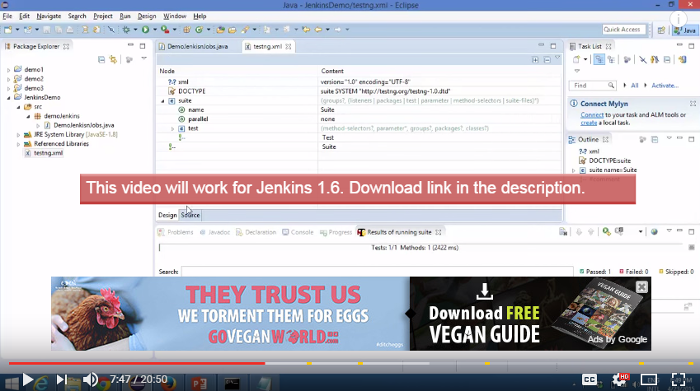

1. Run that project: testing project

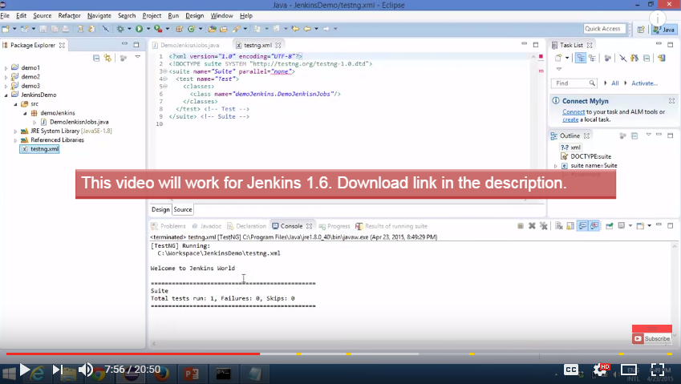

1. Now need to run project from command prompt:

Right Click project 🡪 Properties, Copy the path for workspace and project

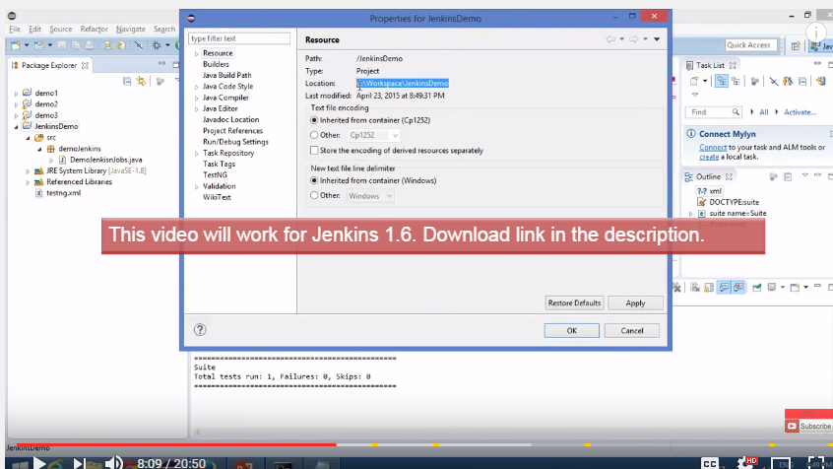

1. Create a new folder where you can put all the libraries. Put all the jar files.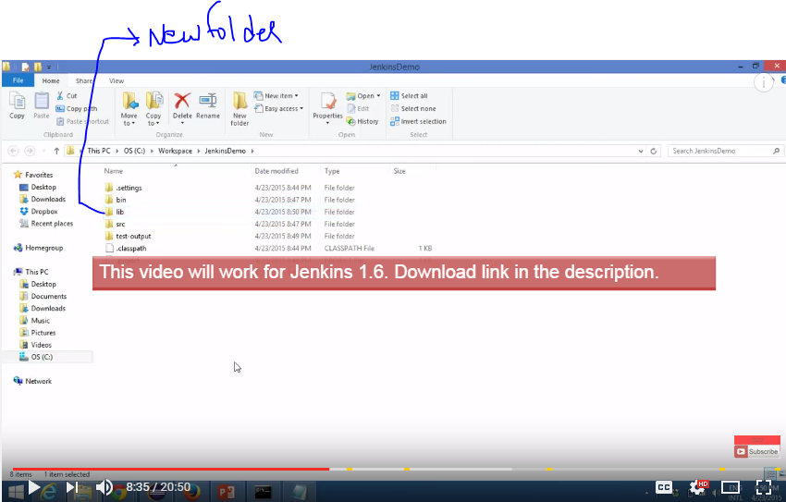

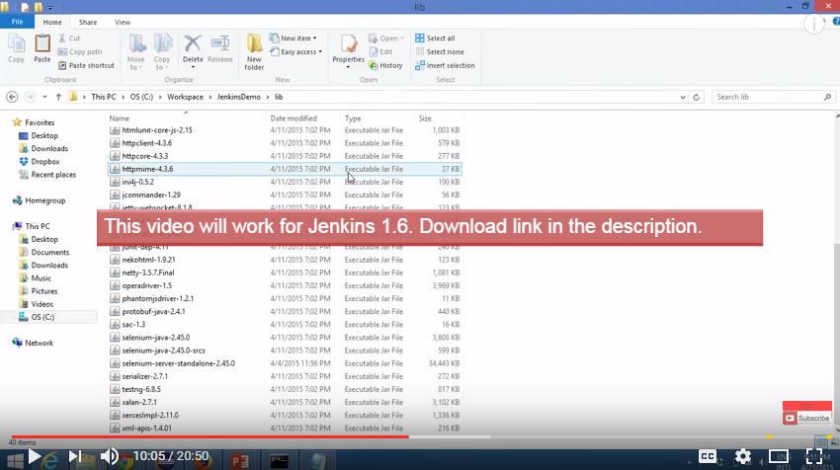

1. **Got to command prompt and navigate to project**

**Set classpath=C:\Workspace\Jenkinsdemo\bin**

**Set classpath=C:\Workspace\Jenkinsdemo\lib\\***

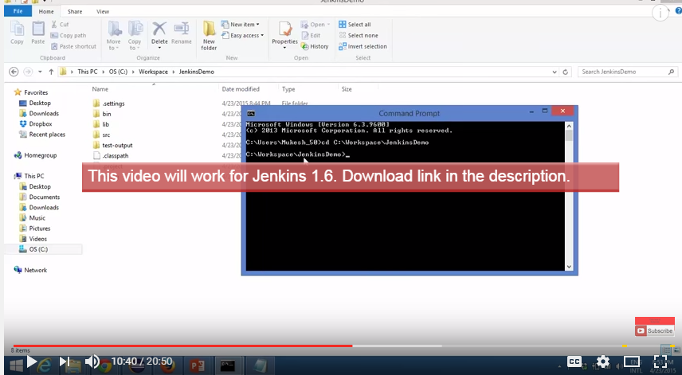

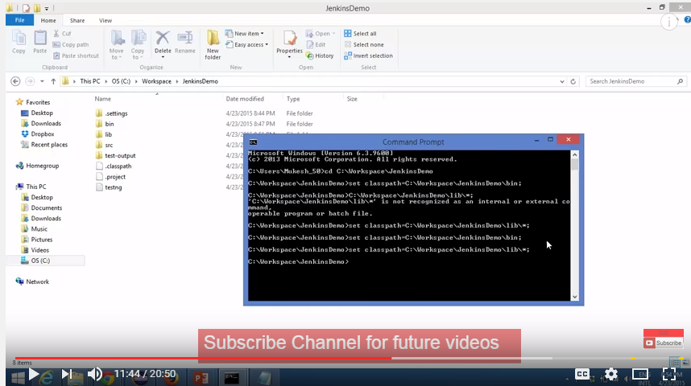

1. Now run testing.xml file

**Java org.testing.TestNG testing.xml**

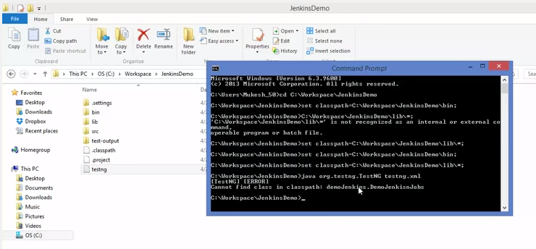

1. IF getting error as cannot find class path then close that command prompt. Again start command prompt.

Again try to run the same.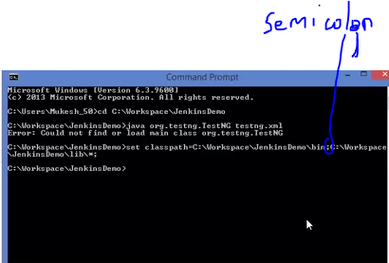

1. Execution successful. Now we are able to execute TesNG program from command prompt.

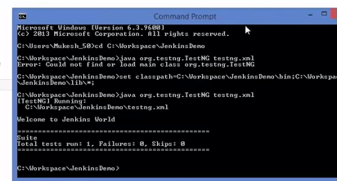

1. Create **a batch file. Save as “run.bat”**

**Java –cp bin;lib/* org.testng.TestNG testing.xml**

**Cp bin– compile binary folder**

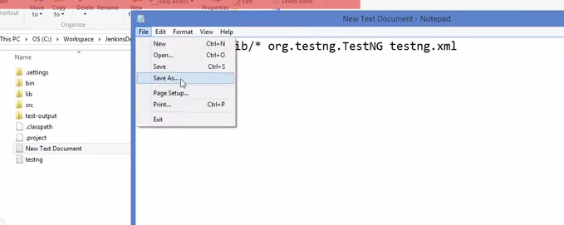

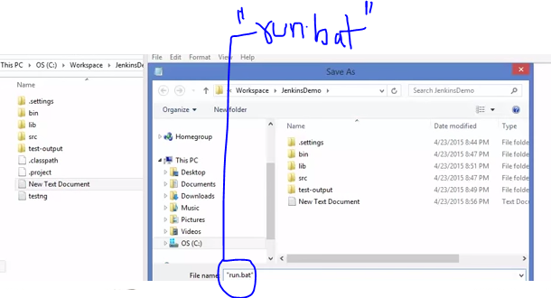

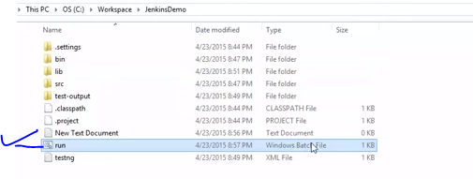

1. If **double** c**l**ick on this. it should run

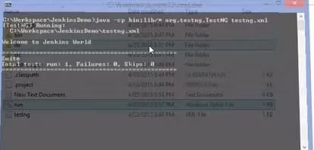

1. **Got to** Jenkins**: Create a new Item, enter the name of item then click on Freestyle project and click on OK.**

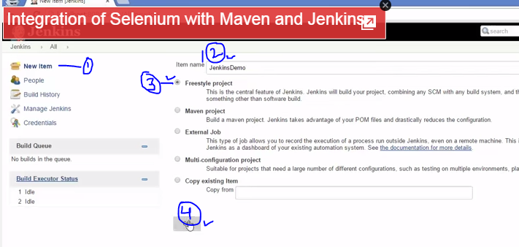

1. Click on Advance Option

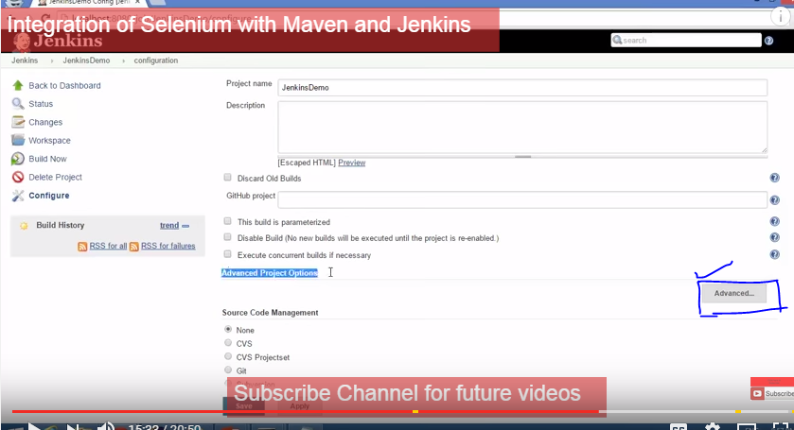

1. Enter the Directory:

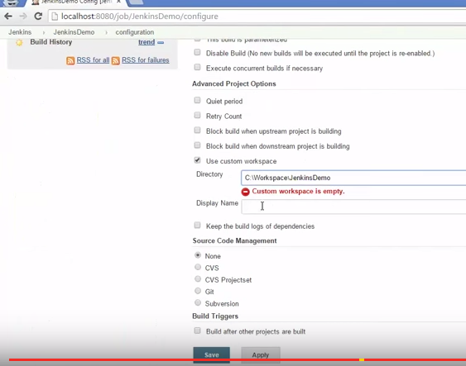

1. Go to Build option, click on execute window batch command

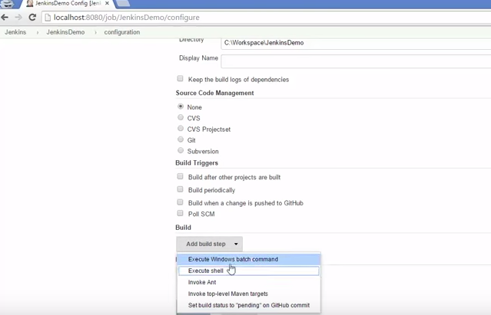

1. Enter the batch file name, click on apply the save.

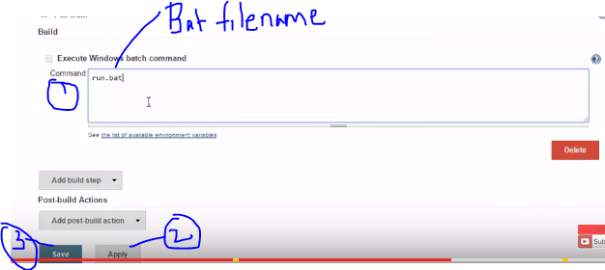

1. Job is ready, then click on Build now

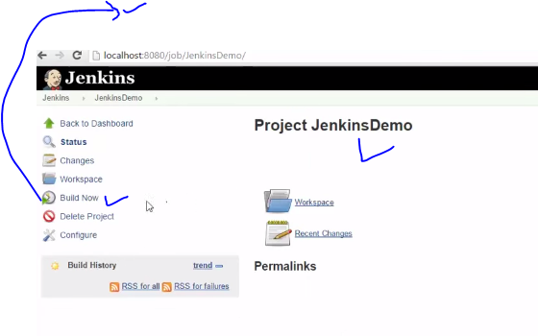

1. Click on Build then click on console output.

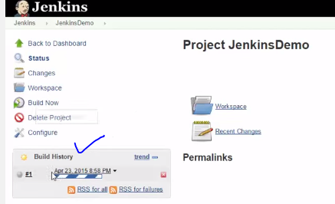

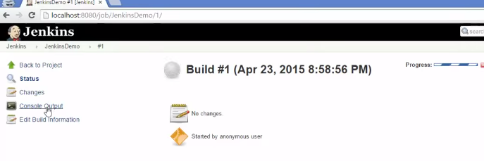

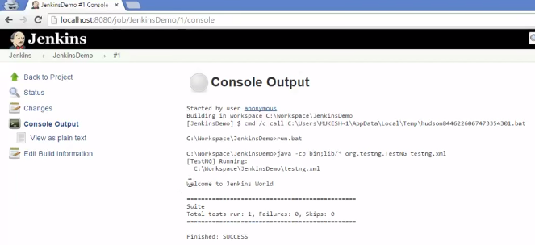

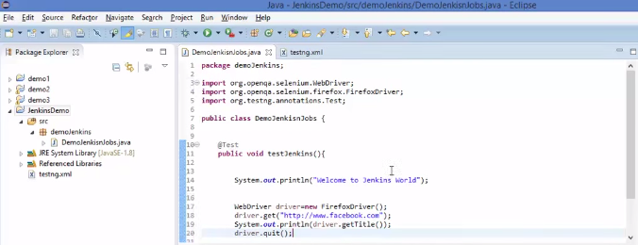

Please note: It will not show UI

